1) Place the .wav file in your MATLAB working directory and start MATLAB.
ex. “a440guitar.wav”
2) Load the .wav file into an array variable.
ex. [y, Fs, nbits] = wavread('a440guitar.wav');
y = 188,416 x 1 array containing each sample (-1 <= y <= 1 y is floating point)
Fs = 44,100 sampling rate (Hz)
nbits = 16 number of bits
3) (Optional) Listen to the .wav file through your computer’s speakers.
ex. wavplay(y, Fs);
4) (Optional) Look at variable y in the array editor of MATLAB by double-clicking on it in the “Workspace” window.
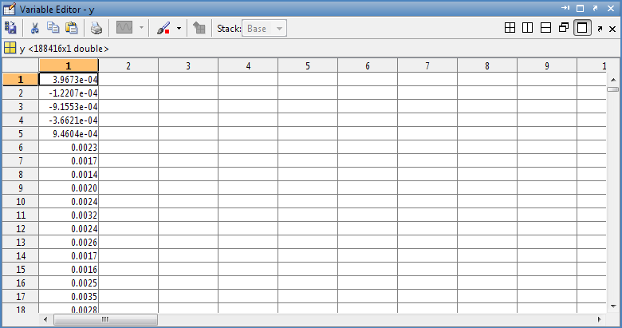
5) Pick a set of points and copy into Excel
6) Scale in amplitude and time

